Mid-Semester Evaluation Project Report
on
Parameter Estimation of Hyperelastic Materials

Submitted by:
Kapil Bansal (Reg. No.: 20215097)
Mannana Rithik Varma (Reg. No.: 20215163)
Aditya Narayan Goswami (Reg. No.: 20215094)
B.Tech (VII Sem)
Session: 2024


Under the Supervision of:
Dr. Deepak Punetha
DEPARTMENT OF ELECTRONICS AND COMMUNICATION ENGINEERING
MOTILAL NEHRU NATIONAL INSTITUTE OF TECHNOLOGY ALLAHABAD,
PRAYAGRAJ – 211004, INDIA

Acknowledgment

We would like to extend our gratitude to Sir Dr. Deepak Punetha for his invaluable guidance throughout this project. His expertise and insights have been crucial to the successful completion of this work. We would also like to thank the professors of our institution for providing the resources and support needed to carry out this study.

Introduction to Hyperelastic Materials

Hyperelastic materials are a unique class of materials that exhibit non-linear elastic behavior, especially when subjected to large deformations. Unlike traditional materials that maintain linear elasticity under stress, hyperelastic materials are capable of withstanding extreme stretches while returning to their original shape upon release. This unique capability makes them ideal for applications where flexibility, durability, and resilience are paramount. Their significance spans across multiple industries, including electronics, healthcare, and civil engineering. Particularly in the electronics industry, hyperelastic materials play a pivotal role in wearable technology, electronic skins, and sensors, where durability and flexibility are essential.
The Ogden material model is one of the most widely adopted models for describing the behavior of hyperelastic materials. It accounts for the non-linear stress-strain relationship seen in materials like rubbers and polymers, providing a more accurate representation of their mechanical behavior under various loading conditions. By utilizing strain energy density functions, the model helps in predicting the response of hyperelastic materials, aiding industries in optimizing material selection and design.

Model Definitions: Ogden Material Model

The Ogden material model is a mathematical framework used to describe the mechanical response of hyperelastic materials under large deformations. The strain energy density function of the Ogden model is defined as: 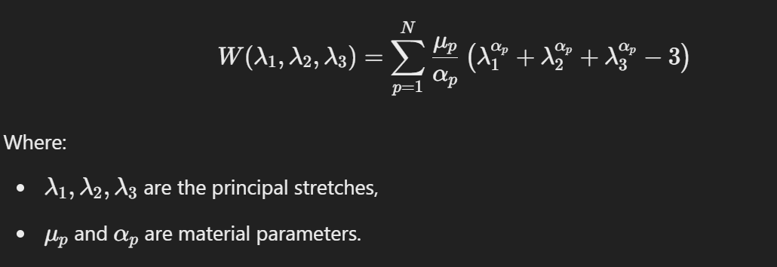
The model parameters are usually determined through experimental data, ensuring that the material’s response is accurately captured. The Ogden model provides a robust framework to simulate hyperelastic behavior in finite element analysis software, enabling researchers and engineers to model large strain effects in materials.

Applications of Hyperelastic Materials

1. Electronics and Wearable Technology:
- Hyperelastic materials are extensively used in wearable sensors, electronic skins, and flexible electronic components. Their ability to stretch and bend without breaking makes them ideal for such dynamic applications.

2. Medical and Healthcare:
- In the medical sector, hyperelastic materials find applications in surgical gloves, medical implants, and prosthetics, where biocompatibility and elasticity are vital.

3. Automotive and Aerospace:
- Materials such as rubber and polyurethane are commonly used in tires, seals, gaskets, and shock absorbers. Their high durability and flexibility under stress are key factors for their adoption in these industries.

4. Consumer Goods:
- Hyperelastic materials contribute to the development of sports equipment, footwear, and toys. These applications benefit from their high elasticity and comfort.

5. Civil Engineering:
- Hyperelastic materials are also used in expansion joints and bridge bearings, where their resilience to repeated stress ensures structural integrity over time.

Categorization of Hyperelastic Materials

Hyperelastic materials can broadly be categorized into polymers and oxides.

Polymers
1. Best Polymer: Silicon Rubber
- Silicon Rubber is considered best among hyperelastic materials.
- It shows large deformations under applied stretch.
- It is widely accessible as well as has great performance.
- It is chemical resistant and biocompatible.

Other notable polymers include:
- Nitrile Rubber: Known for its resistance to oils and chemicals.
- Natural Rubber: Widely used for its high tensile strength and elasticity.
- Polyurethane: a versatile polymer known for its durability, flexibility, and resistance to abrasion, making it ideal for use in a wide range of applications, from insulation materials and coatings to flexible foam products used in the electronics and automotive industries.

Oxides
1. Best Oxide: Silicon Oxide (SiO₂)
- Silica (SiO2) can be considered as best hyperelastic oxide.
- It shows superior stress-strain behaviour.
- It shows better tear resistance.
- It is highly compatible with other hyperelastic materials.

Other oxides include:
- Titanium Oxide(TiO2) : It is widely used in electronic devices and coatings due to its optical properties and flexibility in thin films.
- Alumina (Al₂O₃): Frequently used for its hardness and thermal stability.
- Zinc Oxide (ZnO): Utilized for its piezoelectric properties in electronics.

Use of COMSOL Multiphysics for Analysis

COMSOL Multiphysics is a powerful simulation software used to model the behavior of hyperelastic materials under different conditions. In this project, the Ogden material model is implemented to analyze the stress-strain relationships in polymers and oxides.

- For Polymers: The stress-strain curves for materials like Polyurethane and Silicon Rubber were analyzed, providing insights into their deformation limits and recovery properties. COMSOL allows for detailed parametric studies, making it easier to optimize material selection based on specific application requirements.

- For Oxides: The performance of Titanium Dioxide and Alumina was studied under thermal and mechanical stress. The software’s multiphysics capabilities enable a thorough evaluation of material properties under combined physical effects, ensuring that the materials can withstand real-world operational environments.

Conclusion

The realm of hyperelastic materials is vast and ever-expanding, encompassing a diverse range of materials that exhibit extraordinary elasticity and durability. In this project, we focused on a few key materials like Polyurethane and Titanium Dioxide, which stand out due to their superior mechanical properties and wide-ranging applications. However, this is merely a glimpse into the ocean of hyperelastic materials available today, each with unique characteristics that cater to different industrial needs. As industries continue to evolve, so will the demand for innovative hyperelastic materials, driving further research and development in this fascinating field.

